Name: PROACTIVE CHURN PREDICTION & RETENTION PLATFORM

githubUrl: https://github.com/tejaswinikuchi/ProjectSpace-PS60.git
Description: A ServiceNow-based AI-powered platform that predicts customer churn risk using customer usage, support, and billing data. The system classifies customers into risk categories, generates AI-based retention recommendations, automates alerts and workflows, and provides dashboards for monitoring customer health and intervention effectiveness.

Functional Requirements :
Customer Data Management
- Maintain customer profile records with usage, billing, and support history
- Import customer data from external CRM and support systems via REST API
- Support manual override of AI-generated risk scores by account managers
Churn Prediction Engine
- Compute a Churn Risk Score (0-100) for each customer using ML (Predictive Intelligence)
- Classify customers into Low, Medium, High, or Critical risk categories
- Generate AI-based explanation of risk factors per customer using OpenAI API
- Run automated nightly scoring on all active customer records
Retention Recommendations
- Generate 3 personalized retention action recommendations per at-risk customer
- Recommendations tailored to subscription tier, usage pattern, and contract value
- Display AI recommendations directly on customer record and in alert emails
Workflow Automation
- Send automated email alerts to account managers when risk changes to High or Critical
- Automatically create retention task records pre-filled with AI recommendations
- Post real-time Slack/Teams notifications on risk escalation events
- Schedule follow-up reminders if intervention tasks remain open beyond 48 hours
Dashboard & Reporting
- Provide real-time executive dashboard with churn trends, KPI cards, and risk heatmaps
- Generate automated weekly churn summary reports sent to leadership
- Track every retention intervention with outcome recording and before/after risk scores
Access Control & Integration
- Role-based access control with Admin, Account Manager, Analyst, and Executive roles
- Account managers restricted to viewing and editing only their assigned customer records
- Integration with Salesforce CRM, Zendesk Support, and Stripe Billing via REST APIs
- Virtual Agent chatbot for internal team queries on customer risk and workflow triggering

Non-Functional Requirements :
- Dashboard pages must load in under 3 seconds for all user roles
- Churn risk score computation for a single customer must complete within 5 seconds
- Email notification dispatched within 60 seconds of a risk threshold breach
- Supports multiple external API integrations through IntegrationHub.
- Platform designed to support large customer datasets efficiently.
- Data is securely transmitted and stored using standard encryption methods.
- OAuth 2.0 authentication for all external API integrations
- All CRUD operations on customer records logged in ServiceNow Audit History
- All scripts must include inline documentation; Update Sets used for all changes

Problem Statement: Subscription-based SaaS companies lose significant revenue to customer churn every year. The core issue is that most churn is predictable — customers show warning signals like declining usage, rising support complaints, and low engagement weeks before cancelling. Without an intelligent early-warning system, account managers only become aware of the problem after the customer has already left. Current approaches rely on exit surveys, manual CRM reviews, and ad-hoc outreach, which are too slow and inconsistent to scale. There is no real-time monitoring of customer health indicators, no data-driven prediction of churn likelihood, and no measurable tracking of whether retention efforts actually work.

Proposed Solution: A ServiceNow-native AI-powered Churn Prediction and Retention Platform that aggregates customer data from CRM, support tickets, and billing systems, then applies Machine Learning (Predictive Intelligence) to compute a Churn Risk Score for every customer. The system automatically alerts account managers when risk crosses a threshold, uses the OpenAI API to generate personalized retention recommendations, automates task creation and follow-up workflows via Flow Designer, and provides executive dashboards with churn trends and ROI reporting built on Performance Analytics. Every retention intervention is tracked and measured to create a continuous improvement feedback loop.

Technologies Used: ServiceNow, Predictive Intelligence, Flow Designer, IntegrationHub, OpenAI API, REST APIs, Performance Analytics, Virtual Agent, Python, and external CRM/support integrations.
System Architecture: The platform follows a five-layer architecture. The Data Ingestion Layer uses IntegrationHub REST connectors and webhook receivers to pull customer data from Salesforce, Zendesk, and Stripe every 6 hours. The Data Storage Layer stores customer profiles, usage snapshots, risk score history, and intervention records in custom ServiceNow tables. The AI/ML Processing Layer runs Predictive Intelligence for churn scoring and calls the OpenAI GPT-4 API for retention recommendations and risk explanations. The Automation Layer uses Flow Designer workflows to handle risk alerts, task creation, follow-up scheduling, and Slack notifications. The Presentation Layer delivers real-time dashboards through Performance Analytics and a Service Portal for account manager interactions.

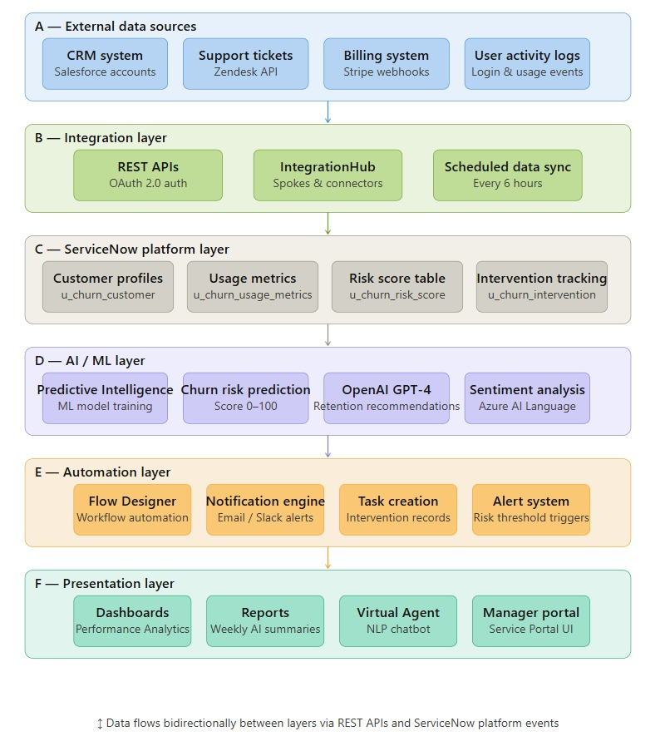

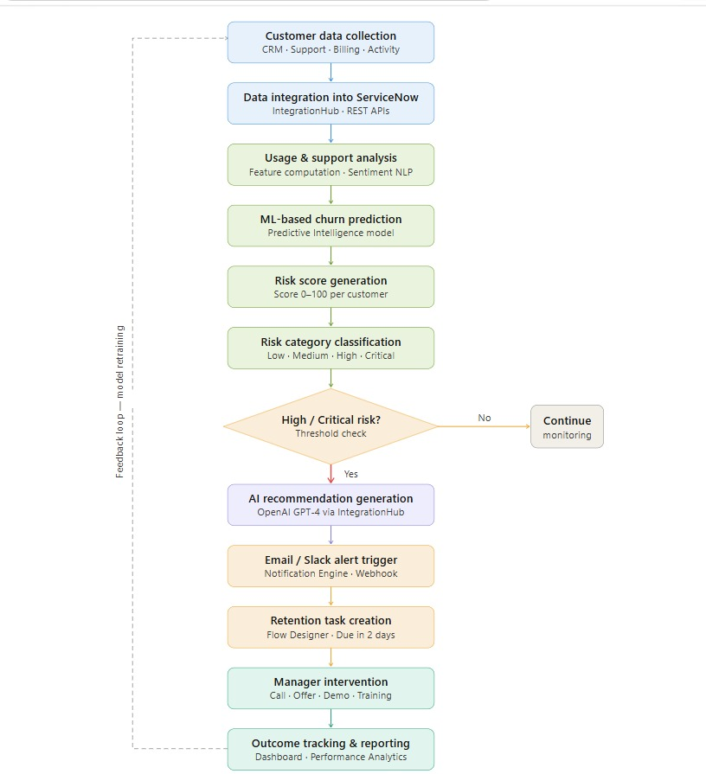

in_scope: Customer data management with CRM, support, and billing integration; churn risk prediction using Predictive Intelligence; customer risk category classification; AI-based retention recommendations using OpenAI API; automated email and notification workflows using Flow Designer; dashboard reporting with KPI charts and risk analysis; intervention tracking and follow-up management; role-based access control; Virtual Agent support for account managers; and basic REST API integrations with external systems.

out_scope: Native mobile application support; advanced real-time streaming systems; multilingual AI processing; enterprise-level ERP integrations; voice-based AI assistants; and advanced custom machine learning model development outside the ServiceNow platform.

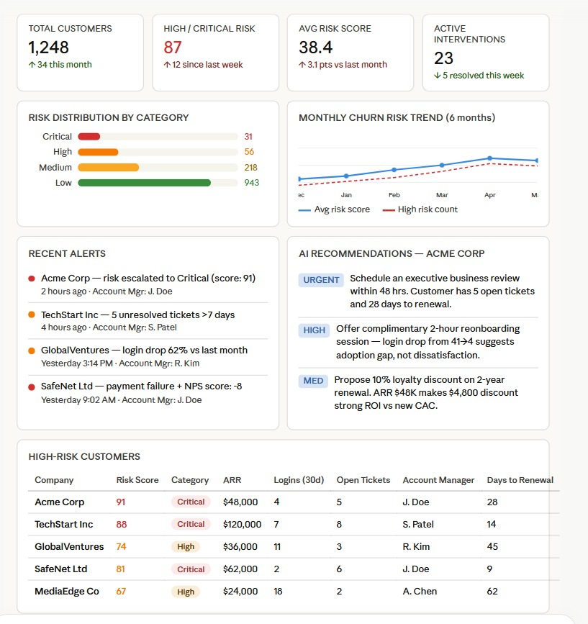

Future Enhancements:
- Real-time customer activity monitoring and faster risk prediction updates
- Improved machine learning models for better churn prediction accuracy
- Customer Lifetime Value (CLV) prediction module to prioritize retention spend
- Enhanced AI-based recommendation system for personalized customer engagement
- Mobile application support for account managers
- Additional integrations with CRM and customer support platforms
- Advanced dashboard analytics and reporting features
- Multi-language support in Virtual Agent for wider usability

Conclusion: The Proactive Churn Prediction and Retention Platform is a complete AI-driven solution built on ServiceNow that transitions subscription businesses from reactive to proactive customer retention. By combining Predictive Intelligence ML models, OpenAI-generated recommendations, and end-to-end workflow automation, the platform identifies at-risk customers weeks before cancellation and equips account managers with specific, data-backed action plans. The project covers the full engineering spectrum — platform development, AI/ML integration, REST API connectivity, workflow design, and dashboard reporting — making it a strong academic submission and portfolio showcase.

Project Type: AI-Powered Enterprise SaaS Platform

